MARKING KEY – TEST 2 2017 MATHEMATICS SPECIALIST CALCULATOR FREE

1. (13 marks)

(a) .  (3)

✓

✓✓

(b)

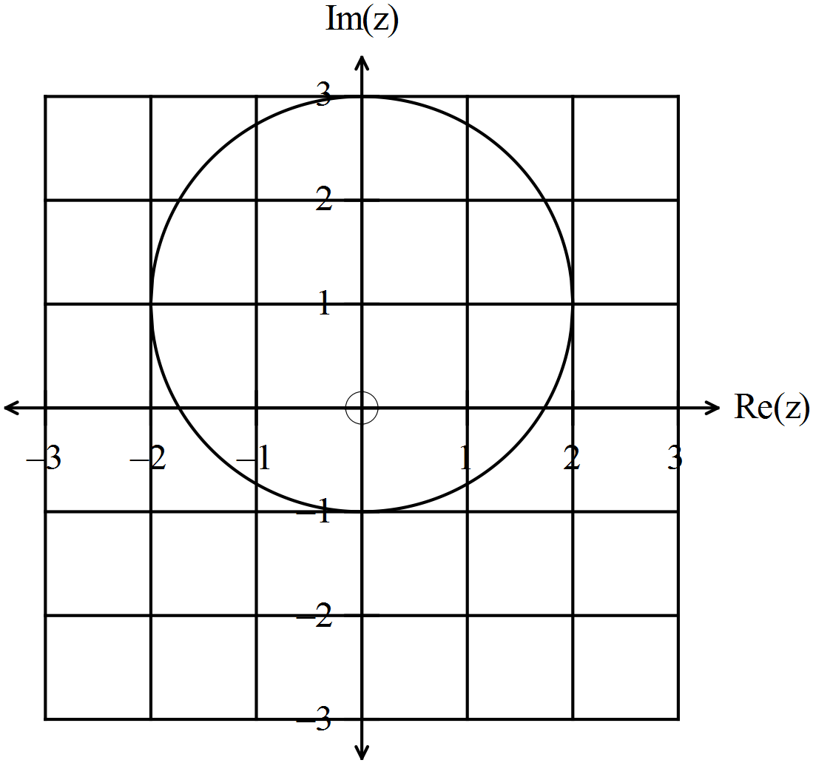

✓✓✓ -1/error

(3)

(c)

 (2)

✓

✓

(d) 

✓ ✓ (2)

(e) (i)  ✓ (1)

(ii)  ✓ (1)

(ii)  ✓ (1)

**Question 2 (9 marks)**

1. If  find the values of  and , where  and are real constants.

(3 marks)

|  |
| --- |
| **Solution** |
| Equating the real parts:  Equating the imaginary parts: |
| **Specific behaviours** |
| 🗸 correctly expands  🗸 equates real and imaginary parts  🗸 correctly states corresponding values of  and |

1. The complex number  is transformed to its reciprocal .
2. What is the reciprocal of  in the form ? (2 marks)

|  |
| --- |
| **Solution** |
| = |
| **Specific behaviours** |
| 🗸 multiplies by  🗸 simplifies to arrive at the correct result |

1. State the reciprocal of  in polar form. (2 marks)

|  |
| --- |
| **Solution** |
| and  = =  =  in polar form. |
| **Specific behaviours** |
| 🗸 determines =  🗸 correctly states  in polar form |

1. Given *z* is a complex number, express the modulus and argument of  in terms of  and . (2 marks)

|  |
| --- |
| **Solution** |
|  |
| **Specific behaviours** |
| 🗸🗸states the correct relationship for the modulus and the argument |

**Question 3**

Since *P(x)* is monic it can be factorised as 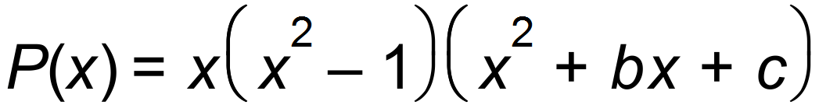 ✓

Then, by expanding and comparing coefficients:

**

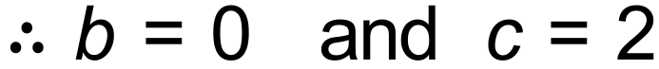 ✓✓

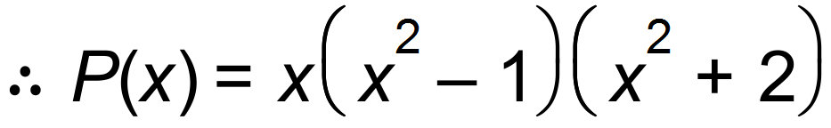 ✓

(Long division of polynomials is also an alternative)

Also, 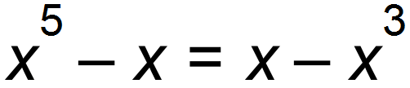 becomes 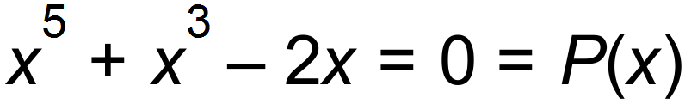 and therefore the

solutions are: 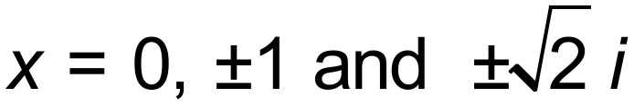 ✓ [5]

4 (a)

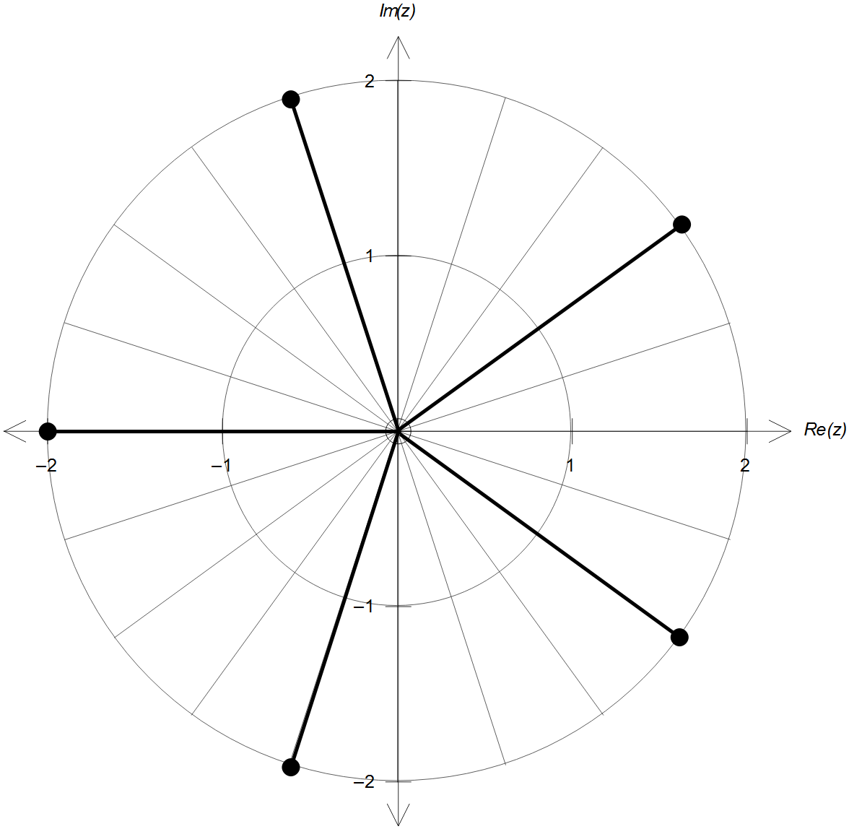

✓ magnitude = 2

✓ 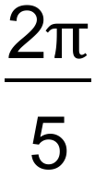 radians apart

(b) 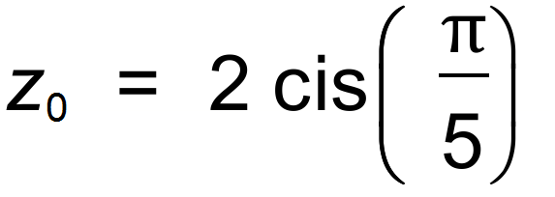, hence 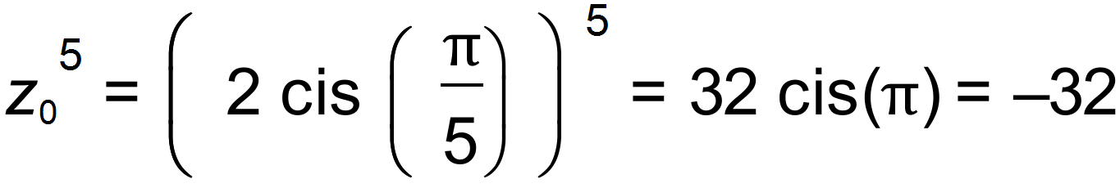 ✓

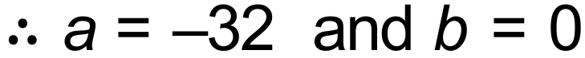 ✓

(c) Other solutions can be obtained using 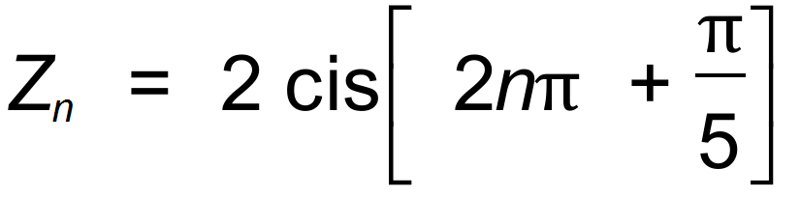 with *n* = 0, 1, 2, 3, 4

or graphically. Therefore, the solutions are:

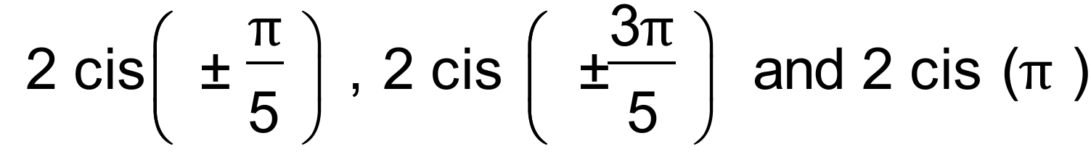 ✓✓✓ [7]

MARKING KEY – TEST 2 2017 MATHEMATICS SPECIALIST CALCULATOR ASSUMED

5. (a) 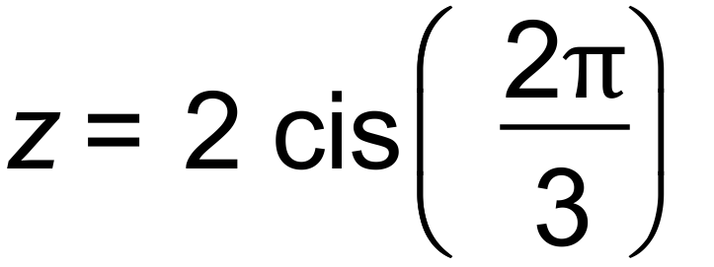 ✓

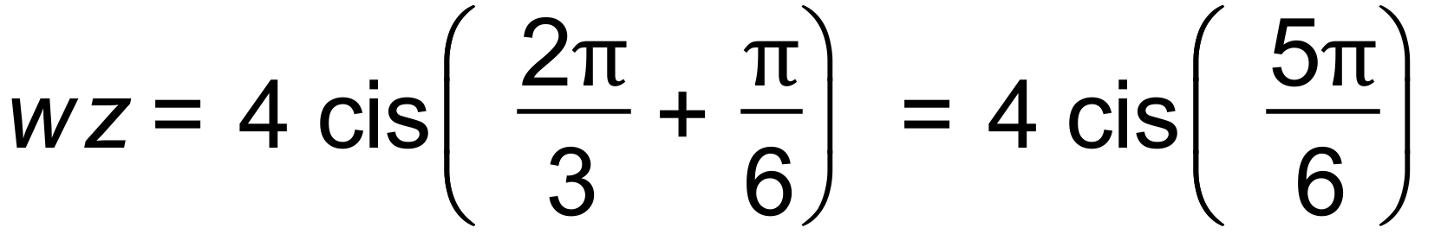 ✓✓

(b)

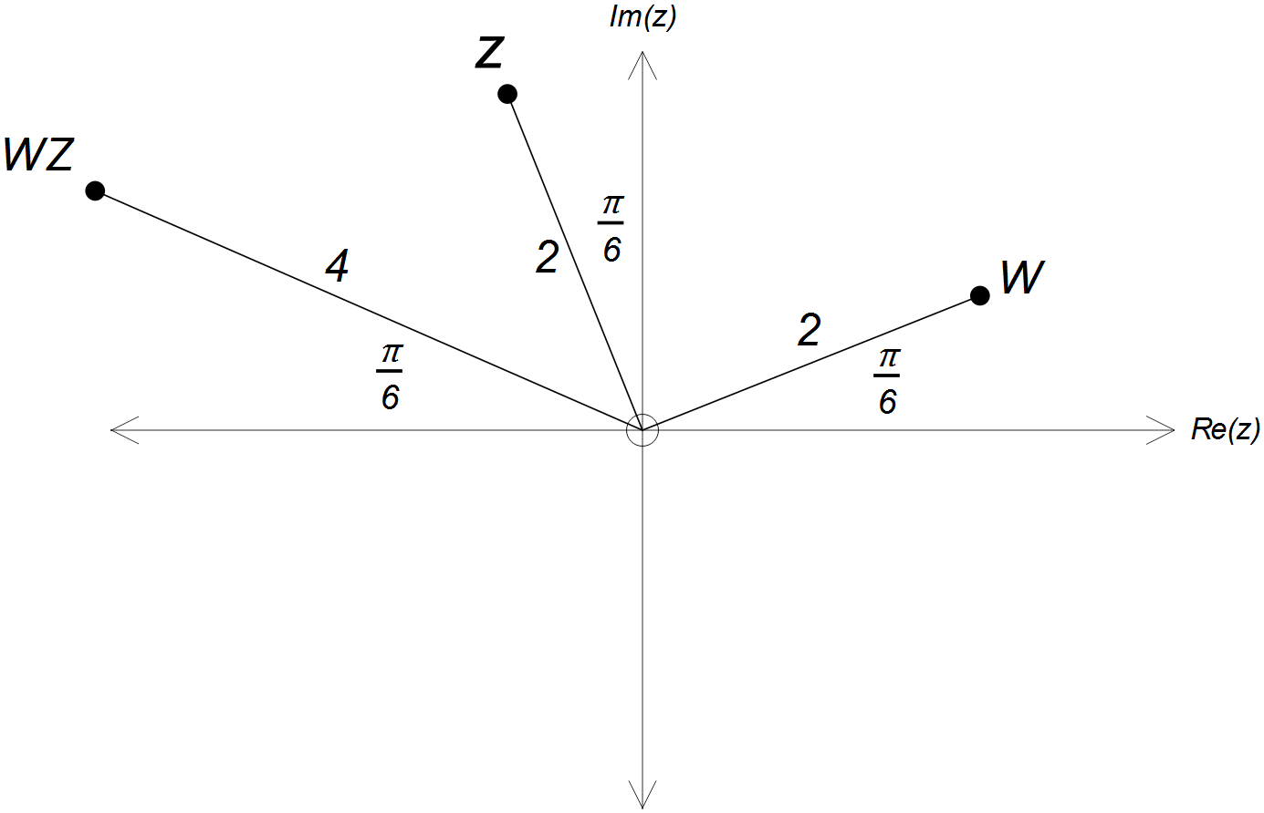

✓ correct magnitudes

✓ correct arguments

✓ correct magnitudes

✓ correct arguments

**Question6 (7 marks)**

A complex number , is defined by  and .

1. On the polar grid below, graph the sequence  for integers, . (4 marks)

|  |
| --- |
| **Solution** |
| Evaluate  and  for each value of  within the given domain.   |  |  |  |  |  |  |  |  |  |  | | --- | --- | --- | --- | --- | --- | --- | --- | --- | --- | |  | 0 | 1 | 2 | 3 | 4 | 5 | 6 | 7 | 8 | |  | 1 |  | 2 | 2 | 4 | 4 | 8 | 8 | 16 | |  | 0 |  |  |  |  |  |  |  |  |   Plotting the points gives … |
| **Specific behaviours** |
| 🗸 Calculates correct values  of  for  🗸 Calculates correct values  of  for  🗸 Plots points correctly : mod  🗸 Plots points correctly : arg |

1. Hence or otherwise find the value(s) of *,* where  is an integer  ,

such that  and . (3 marks)

|  |
| --- |
| **Solution** |
| For ,  since  for and  For ,  and  Solution: |
| **Specific behaviours** |
| 🗸 Recognises that < 4 for  🗸 Recognises that < 4 for  🗸 Recognises that and  for |

Question 7

= 🗸

= 🗸

*Equating real parts*

*=* 🗸

*=*  🗸

*=*

*= 4-* 🗸